Front view

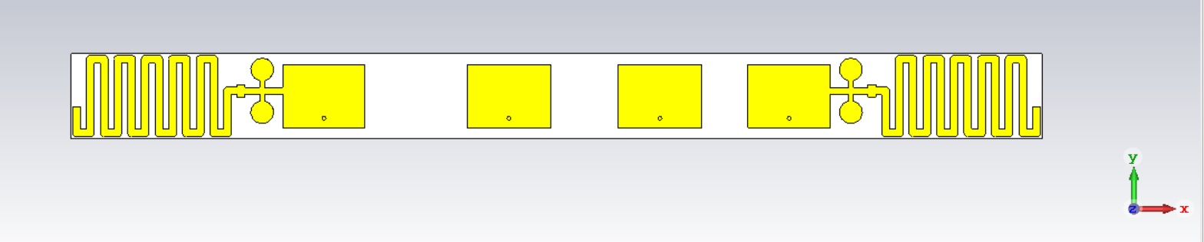

Back view

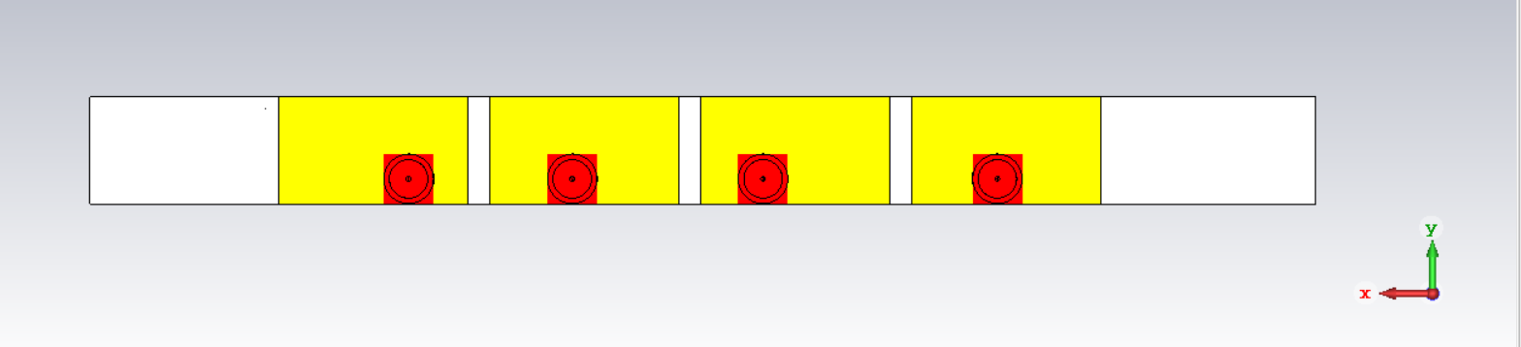

Sf at 3.6719 port 1

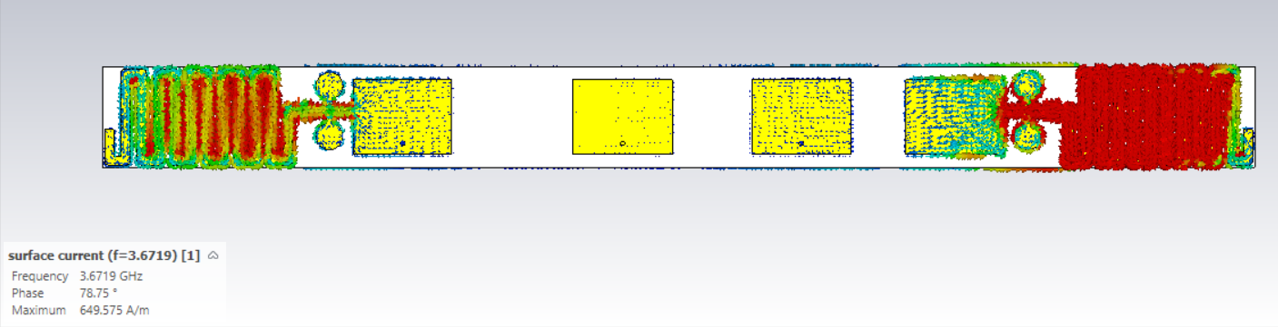

Sf at 24.231 port 1

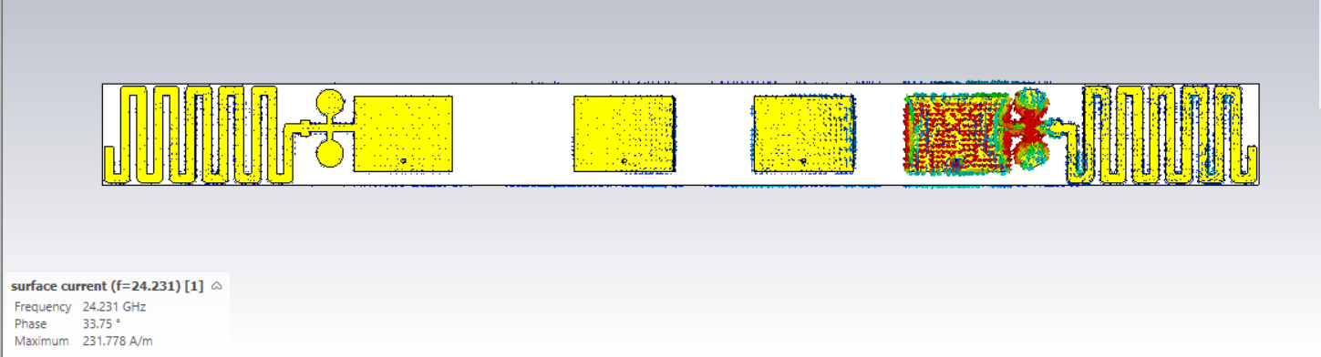

Sf at 3.6719 port 2

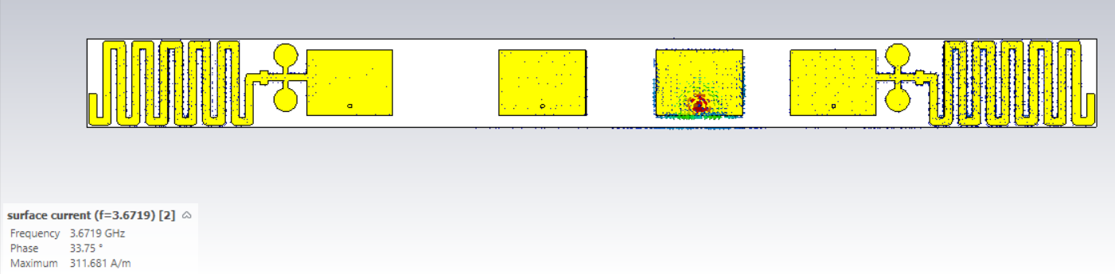

Sf at 24.231 port 2

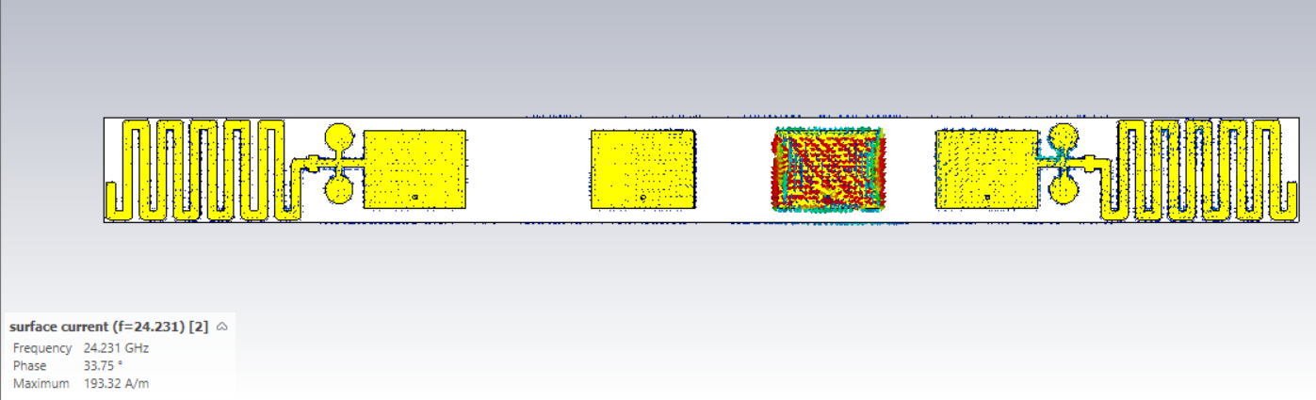

Sf at 3.6719 port 3

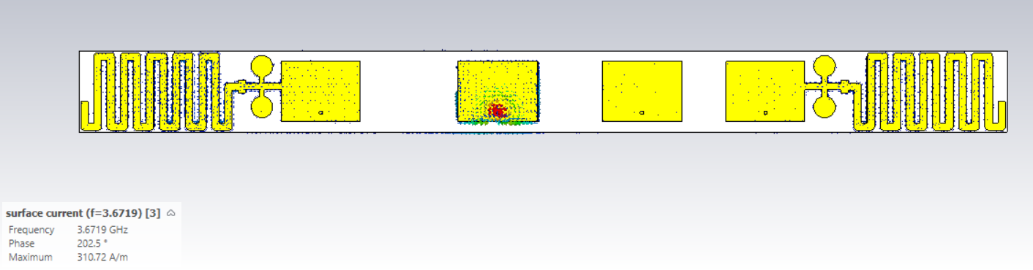

Sf at 24.231 port 3

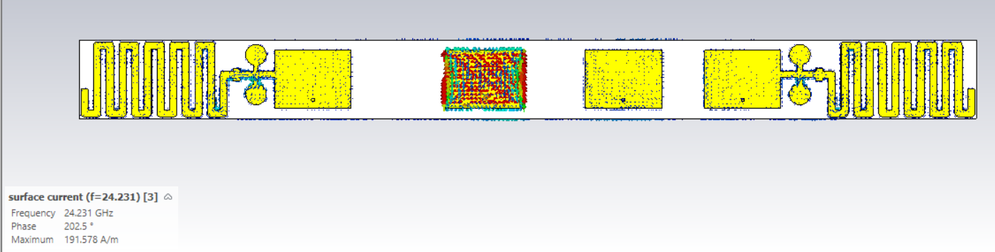

Sf at 3.6719 port 4

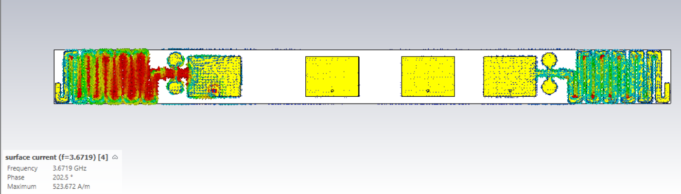

Sf at 24.231 port 4

